**Website**

**Testing plan**

**Café Director**

**Created by Jorge Bernal**

**Student Number 7106644713**

**2015**

Table of Contents

1 Introduction 2

1.1 What is website testing and why is it important? 2

1.1.1 Website address (URL) 2

1.1.2 Website screenshot 2

1.1.3 Responsive design 2

2 Website Test Plan 6

2.1 Types of website testing 6

2.1.1 Functionality testing 6

2.1.2 Performance testing 6

2.1.3 Compatibility testing 7

2.2 Test plan checklist 8

2.2.1 Pre-launch checklist 8

2.2.2 Post-launch checklist 8

3 Website Testing Requirements & Criteria 9

3.1 Requirements for website testing 9

3.2 Website testing environment 9

3.3 Website testing goals 9

3.4 Website tester information 9

4 Security Policy 10

5 Privacy Policy 11

5.1 Summary of results 12

5.2 Overall conclusion 12

5.3 Overall recommendation 12

# Introduction

## What is website testing and why is it important?

When creating a website, we must make the specification and development process, they are large and complex processes therefore it requires going through a testing process to assess the most important elements in functionality and meet the goals of the web site. The website is the management of coffee stores that has to be delivered to the customer all the information. Also the director can check the information of all stores

### Website address (URL)

<http://jfbwebstudio.com/WDV3/>

### Website screenshot

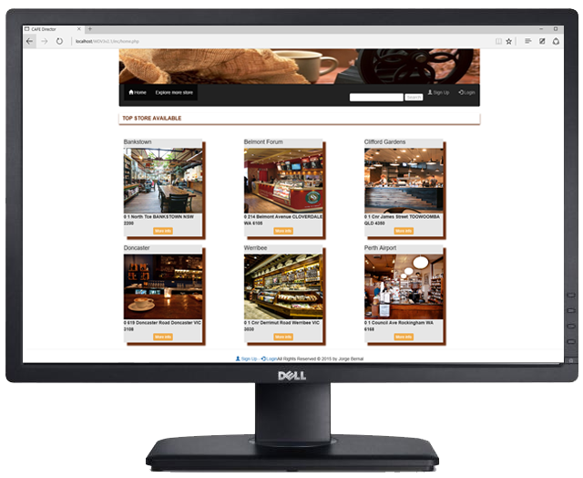

### Responsive design

In developing the website, the technology that helps responsive design was used as Bootstrap and JavaScript.

|  |  |
| --- | --- |
| Home page - MacBook Air with Chrome |  |
| Home page - Mini IPad |  |
| Home page – IPhone 4 |  |
| Stores page - MacBook Air with table |  |
| Stores page – Mini IPad with table |  |
| Stores page – Nexus 7 with table |  |
| Stores page – IPhone 4 with table |  |

# Website Test Plan

## Types of website testing

### Functionality testing

Functional testing has always been important in the development of software, and we can find methods and tools to do these tests, the last years we realise that functional testing is essential in the development of website because we can find some error such as page no found or not loaded images, creating bad user experience. Functional testing helps ensure that most of the functionality was checking.

Tools for functional testing:

W3C Link Checker

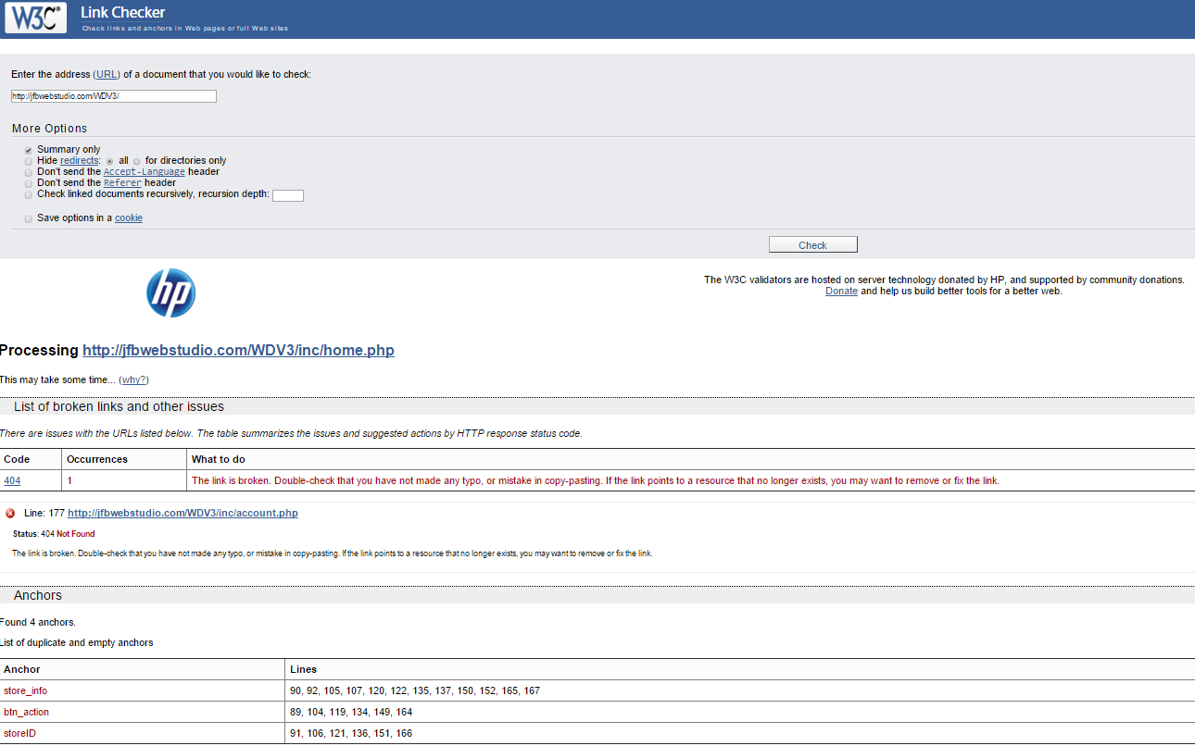

### Performance testing

Performance testing on websites is important, we must analyse the environment of the website to be used and testing the capacity the webserver to support all the activities the users do on website. The common performance testing we can be found is stress load, and it test how many user can support at the same time, additionally this test allows us to know how much we need to scare the infrastructure to support all the user we want.

GTmetrix

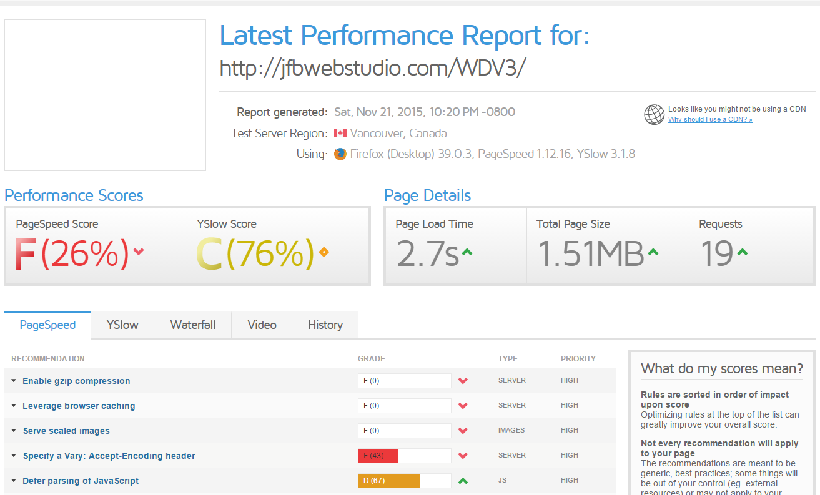

### Compatibility testing

Compatibility testing is useful to ensure the website work in different environment like operating systems or browsers, if the website working in many browsers and devices such as mobile the website can get more audience, and create good user experience. We can check this compatibility with some tools online.

Tools to check compatibility.

Responsivetest

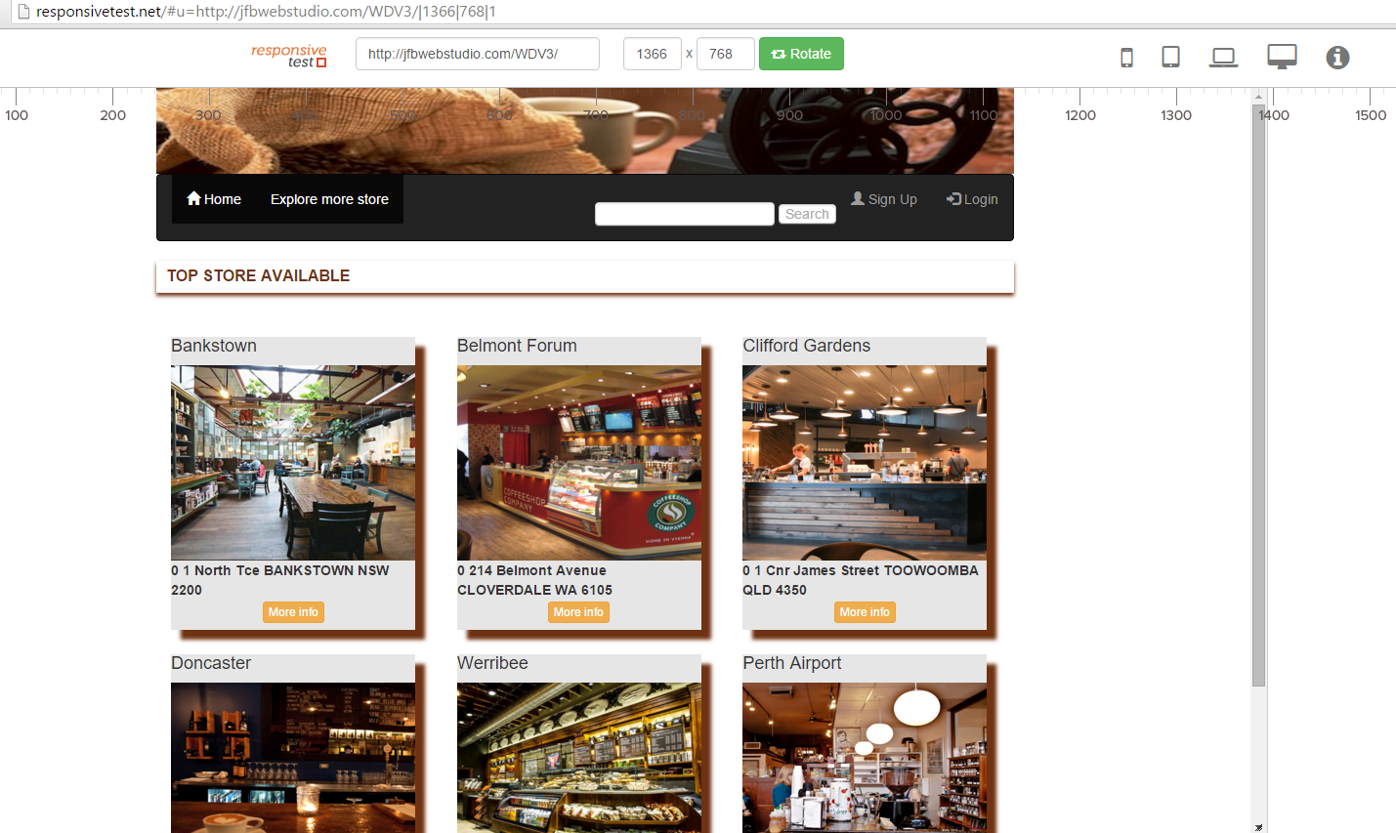

## Test plan checklist

### Pre-launch checklist

* Is your site quick to load?
* Did you forget site search?
* Are the user flows natural?
* Will the user understand the purpose of each page in under 5 seconds?
* Are there any broken links?
* Does it work across all browsers?
* Is it mobile ready?
* Is your branding integrated with the site design?
* Have you tested every user interaction feature multiple times?
* Are your contact details clearly visible?
* Is there a self-help section?
* Is your site optimized for search engines?

Reference Ref 007

### Post-launch checklist

* Verify that Google Analytics is collecting data.
* Check for broken links
* Download backup
* Verify that Google can still read your website
* Set up Google, Bing & Yahoo Webmaster tool accounts

# Website Testing Requirements & Criteria

## Requirements for website testing

After the website finish the development stage, we prepare the website testing stage with the testing plan, the more important things are take the requirement documents from the client and all the information the project expect how is work the website. Also we need the information about which platform used on development stage.

Requirements website document

Mock-up document

Wireframe document

Development document

Tools list

W3C Link Checker

Broken Image Finder

W3C Markup Validation Service

W3C CSS Validation Service

GTmetrix

Load Impact

Checkmycolours

## Website testing environment

The first testing with can use the local server environment on Windows and some clients like Windows 8, Mac OS X, and mobile OS like iOS 8 and Android 4.4, also some browser such as IE, Firefox, Safari, Chrome, and Opera. After functionality testing, accessibility testing, usability testing, compatibility testing if all testings pasted and fixed all warning or errors, we can go to the externally hosted with the same infrastructure specification such as production environment to do the testing about performance and security. When we finish the testing in local server and externally hosted and all the testing pasted, we ready to go to pre-launch checklist and prepare the website to deployment on production server.

## Website testing goals

The main goal is to make the website that meets all the requirements during the planning phase and delivery a quality product on production with standards defined with some organizations such as W3C.

It is expected to have an accessible, functional website with high performance and good security.

## Website tester information

The people who are involved with the testing of the website should be people who worked on the creation of the requirements and some people clients. It should be excluded as the people who worked on the development stage of the application because these people can ignore fundamental elements to be tested or have a different vision of the application. Also people should be present in the testing are the stakeholders and users, and people with skills in planning and design testing and finally the people to running of testing.

# Security Policy

Web applications are subject to security assessments based on the following criteria:

* New or Major Application Release– will be subject to a full assessment prior to approval of the change control documentation and/or release into the live environment.
* Third Party or Acquired Web Application– will be subject to full assessment after which it will be bound to policy requirements.
* Point Releases– will be subject to an appropriate assessment level based on the risk of the changes in the application functionality and/or architecture.
* Patch Releases– will be subject to an appropriate assessment level based on the risk of the changes to the application functionality and/or architecture.
* Emergency Releases– An emergency release will be allowed to forgo security assessments and carry the assumed risk until such time that a proper assessment can be carried out. Emergency releases will be designated as such by the Chief Information Officer or an appropriate manager who has been delegated this authority.

All security issues that are discovered during assessments must be mitigated based upon the following risk levels. The Risk Levels are based on the OWASP Risk Rating Methodology. Remediation validation testing will be required to validate fix and/or mitigation strategies for any discovered issues of Medium risk level or greater.

* High– Any high risk issue must be fixed immediately or other mitigation strategies must be put in place to limit exposure before deployment. Applications with high risk issues are subject to being taken off-line or denied release into the live environment.
* Medium– Medium risk issues should be reviewed to determine what is required to mitigate and scheduled accordingly. Applications with medium risk issues may be taken off-line or denied release into the live environment based on the number of issues and if multiple issues increase the risk to an unacceptable level. Issues should be fixed in a patch/point release unless other mitigation strategies will limit exposure.
* Low– Issue should be reviewed to determine what is required to correct the issue and scheduled accordingly.

Reference Ref 008

# Privacy Policy

Create a Website Privacy Policy

All staff must adhere to the following policies relating to the collection and usage of client information:

Statements that the staff will not do the following unless consent from the client has been received

* Collect information

The information provided by clients will be collected according to the highest standards of safety and reliability.

* Collect sensitive information.

Collect sensitive information compile only if ordered by a legal entity that requires such information, such as the court.

* Personal information.

No personal information may be disclosed outside the company, unless such person is authorized, or that a court order allowing others to have access to such information is taken.

* Protection of personal information

The information will be stored by the standards of security, making their backups, and limited access through passwords and data encryption.

* Period of time to information Some sensitive information will have periods of access, after finished the time, not stored information will be destroyed, and the user will need to log in again the access to stored information.

## Summary of results

## Overall conclusion

The website works generally consistent expectations of the tests. During verification testing some CSS implementation errors were found, they are recommended to be corrected before the deployment. It is required to test the configuration of servers and evaluate the performance of the website in production.

## Overall recommendation

The development platform of website coffee stores, although we can work with CSS and HTML files we can not change the core of the website, it is recommended to have more control and autonomy in the development and testing process like change the PHP files. Also it is recommended to be doing primarily monitoring after launch load testing on the server and evaluate capacity with large users active at the same time.